All Saints’ C. Of E (Aided) Primary School & Nursery Unit
Love to Learn, together with the Lord

Headteacher: Mrs S Partington Moor Road

Chorley

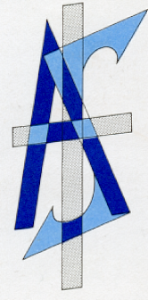
Lancs

PR7 2LR

Tel.: (01257) 262489

Email: head@allsaintscofe.lancs.sch.uk
Web Site: www.allsaintscofe.lancs.sch.uk
Dear Parent/Guardian
Crazy Hair Day - Friday, 20th January 2023

Some of you may be aware, Mrs Ratcliffe has been absent from school since September 2022. She has been diagnosed with triple negative breast cancer, has undergone Chemo and will shortly have an operation to remove the tumour.

She decided to help the wonderful nurses and doctors that are helping her and many others and is raising money and awareness of breast cancer. As she is not fit enough to run marathons she has created her own challenge ‘Wig-on-her’. She has been wearing silly headgear, including wigs and hats when she is well enough to do the school run with her two children, Max and Georgia. Follow her Facebook page (Wig-on-her) and you can look at her array of headgear she has been wearing.

We would like to help with her fundraising this Friday, 20th January with a Crazy Hair Day. We would like the children, staff and parents (on the school run) to decorate their own hair, wear a wig or a silly hat – to support Mrs Ratcliffe and this wonderful cause. Most of all we want to raise awareness and the children to have fun with their ideas.

You can either make a donation on the day in school or directly to the Just Giving Page https://l.facebook.com/l.php?u=https%3A%2F%2Fwww.justgiving.com%2Ffundraising%2FAngela-Ratcliffe3%3Futm_campaign%3Dlc_frp_share_transaction_fundraiser_page_launched%26utm_content%3Dfa7db5a3-25b3-4f0d-965b-fa9602ff4d57%26utm_medium%3Demail%26utm_source%3Dpostoffice%26utm_term%3D1666553182734%26fbclid%3DIwAR0yNu4SlixInkLZTRIbD5s2EQYNriqIbZ423wYrI-TaSAnh7d4xcChyLOQ&h=AT3zqAWHcuQa9qvnyFPDfeCsdTtL3Fxhk8KpTYcNjCkMoyw3yT1v9qsEUitoTe1oLW_D5S3DPYVU9qdGSI75VpjGeuDTkqAqoZGJuTXMP2eVaD6kzgzPF_QJUfduYbPY8cw3rQ
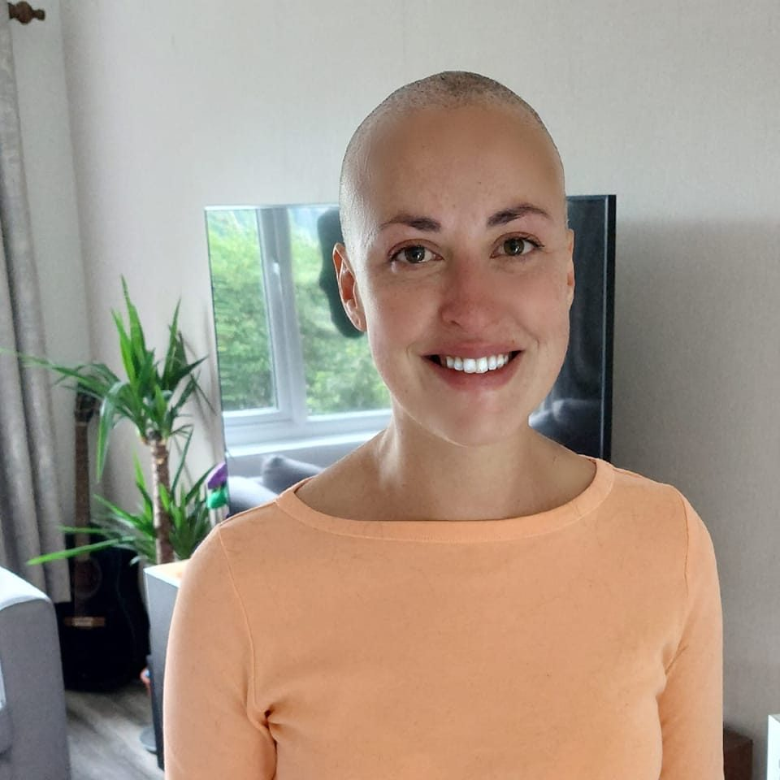
Thank you so much.

